Conjugation Charts
Tense | Person | Number | Pronoun | “Walk” | “Swim” | “Burn” | “Be” | “Have” | “Do”
Present | 1st | Singular | I | Walk | Swim | Burn | Am | Have | Do
Present | 1st | Plural | We/Us | Walk | Swim | Burn | Are | Have | Do
Present | 2nd | Singular | You | Walk | Swim | Burn | Are | Have | Do
Present | 2nd | Plural | Y’all | Walk | Swim | Burn | Are | Have | Do
Present | 3rd | Singular | It | Walks | Swims | Burns | Is | Has | Does
Present | 3rd | Plural | They | Walk | Swim | Burn | Are | Have | Do
Past | 1st | Singular | I | Walked | Swam | Burned | Was | Had | Did
Past | 1st | Plural | We/Us | Walked | Swam | Burned | Were | Had | Did
Past | 2nd | Singular | You | Walked | Swam | Burned | Were | Had | Did
Past | 2nd | Plural | Y’all | Walked | Swam | Burned | Were | Had | Did
Past | 3rd | Singular | It | Walked | Swam | Burned | Was | Had | Did
Past | 3rd | Plural | They | Walked | Swam | Burned | Were | Had | Did
Past Participle |  |  |  | Walked | Swum | Burnt | Been | Had | Done
Present Participle |  |  |  | Walking | Swimming | Burning | Being | Having | Doing
Infinitive |  |  |  | To Walk | To Swim | To Burn | To Be | To Have | To Do
Modals: Seven of Them (Can, Could, Will, Would, Shall, Should, May, Might, Must)
- Modals always require the base form of the verb (Can walk, Could swim, Will be, etc)
  - When you add a modal, verbs do not agree for person or number and use the base form
  - When you add a modal, verbs no longer have tense (neither past nor present) and use the base form
Auxiliary Verbs: Three of Them (Be, Have, Do) – they are only auxiliary verbs when they come before another verb
- Be serves as an auxiliary to form progressive aspect and passive voice
- Have serves as an auxiliary to form the perfect aspect
- Do serves as an auxiliary in the sentence “I do love to ski.”
Tense
- Tense always applies to the FIRST word in the verb phrase.
  - I flew.
  - I was flying
  - I had flown.
  - I did fly.
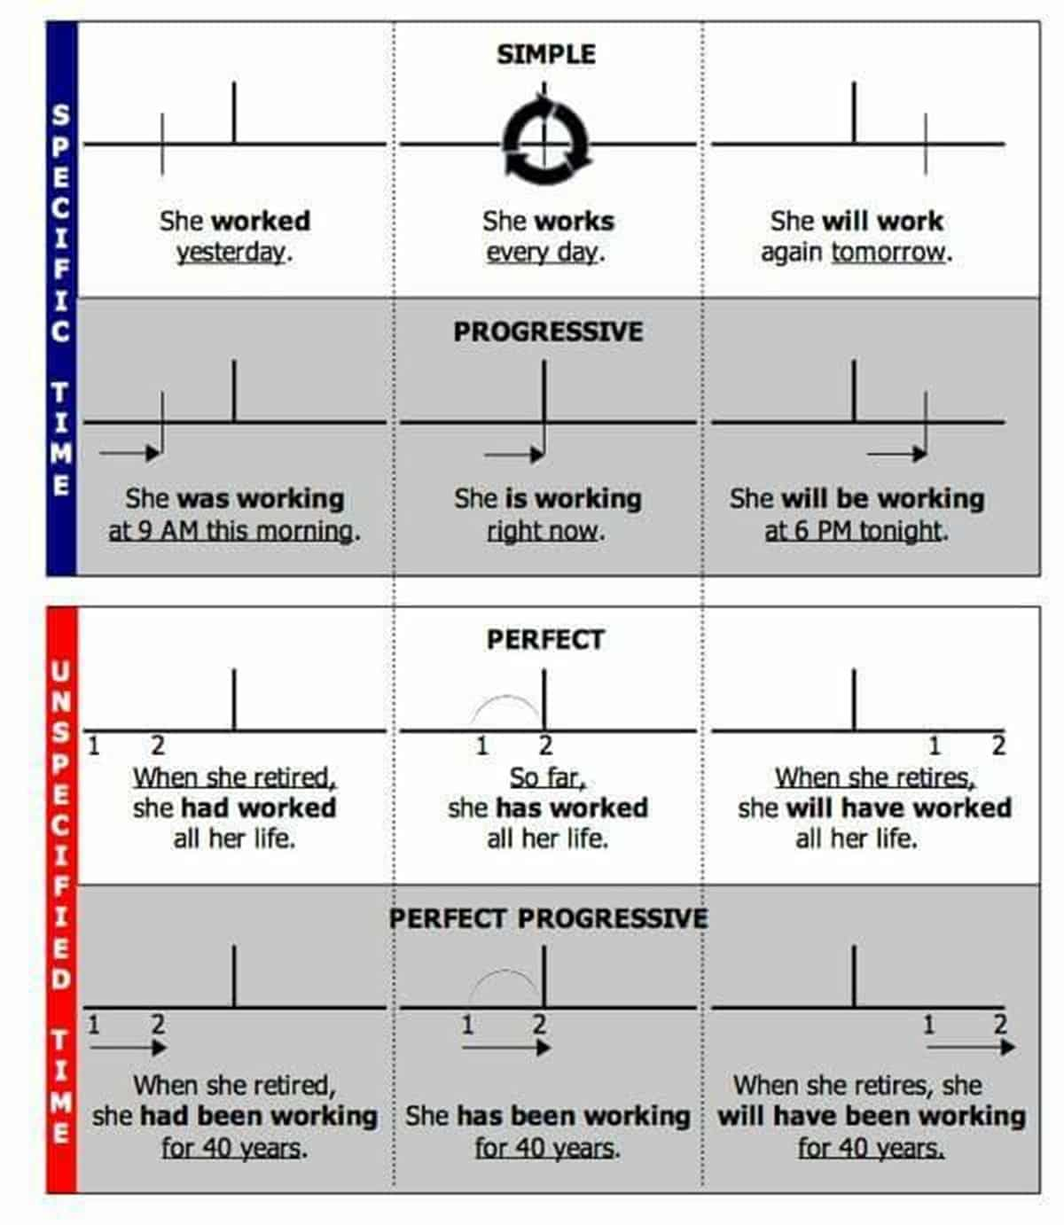
Quick Note
This diagram includes the modal “will” in the third column. Including “will” is a great way to indicate future TIME. However, it is technically inaccurate to call this future “tense.”
When we include a modal like “will,” we use the “base” form of the verb. The verb has no tense (neither past nor present) and is not marked for agreement (person or number).
 | Perfect Aspect | Progressive Aspect | Main Verb
Add a word | Add “Has” | Add “Be”
Change next word | Next word becomes.. Past Participle | Next word becomes.. Present Participle
Past Perfect Progressive | Had | Been | Walking
Present Perfect Progressive | Have | Been | Walking
Past Perfect | Had | --- | Walked
Present Perfect | Have | --- | Walked
Past Progressive | --- | Was | Walking
Present Progressive | --- | Am | Walking
Past Simple | --- | --- | Walked
Present Simple | --- | --- | Walk
Aspect Formation
Passive Voice
- Passive voice moves the receiver of the action to the subject position.
  - The direct object in an active voice sentence becomes the subject in a passive voice.
- The subject from the active voice sentence can be omitted or added in a prepositional phrase
  - Active Voice: I fired the employee.
  - Passive Voice: The employee was fired by me. (original subject as a prepositional phrase)
  - Passive Voice: The employee was fired. (original subject omitted)
- It is formed by adding a “be” auxiliary and changing the original verb to the Past Participle form
  - The dog eats a bone. = Active
  - A bone is eaten by the dog. = Passive
 | Subject | Past Tense | Perfect Aspect | Progressive Aspect | Passive Voice
 |  | (Past Tense) | + Have  (Past Participle) | + Be  (Present Participle) | + Be  (Past Participle)
Present Simple Passive | The ball | Present | --- | --- | Is | Thrown
Past Simple Passive | The ball | Past | --- | --- | Was | Thrown
Present Progressive Passive | The ball | Present | --- | Is | Being | Thrown
Past Progressive Passive | The ball | Past | --- | Was | Being | Thrown
Present Perfect Passive | The ball | Present | Has | --- | Been | Thrown
Past Perfect Passive | The ball | Past | Had | --- | Been | Thrown
Present Perfect Progressive Passive | The ball | Present | Has | Been | Being | Thrown
Past Perfect Progressive Passive | The ball | Past | Had | Been | Being | Thrown

